Case 9-MEX-Colima-Hut Seated Figure-Terra Cotta-300 BCE-300 CE

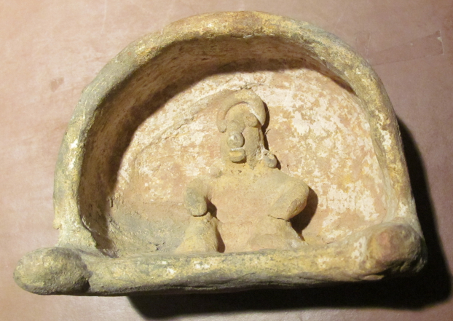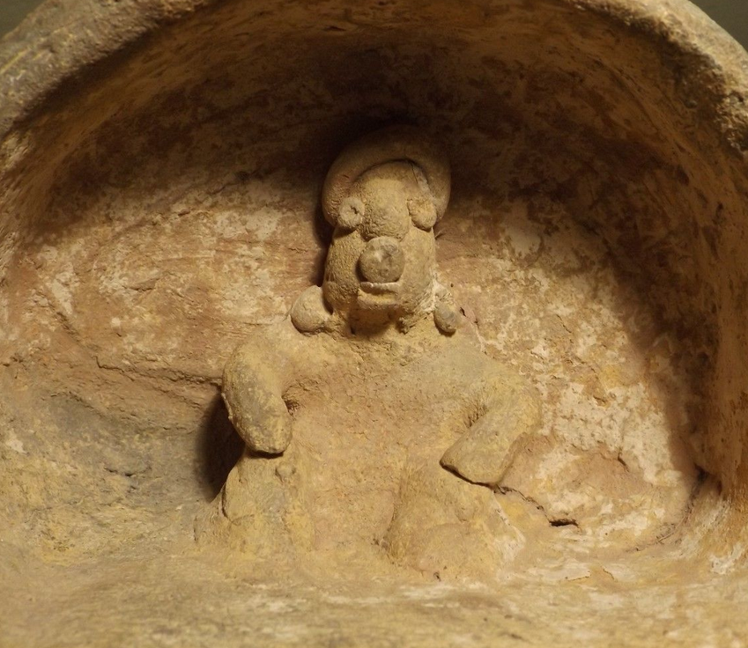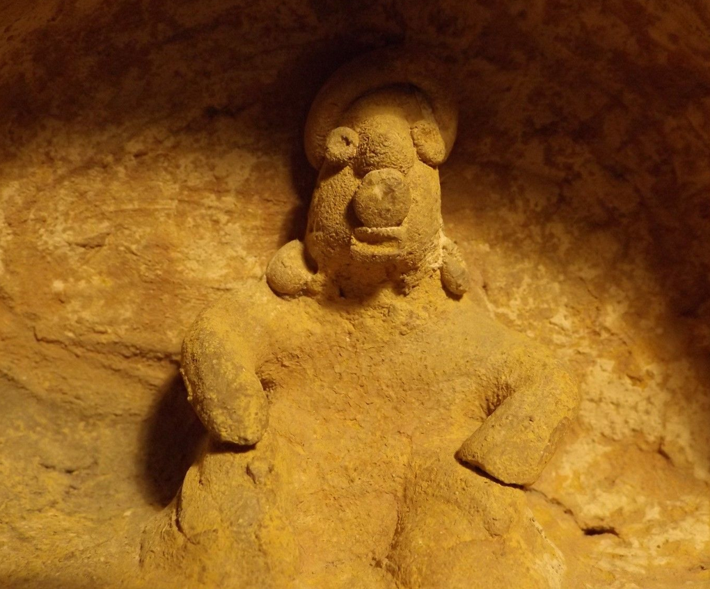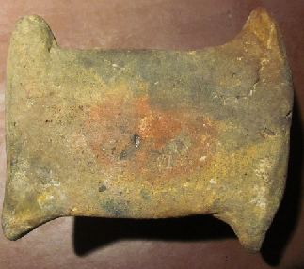

Size 4 3/4" X 3 1/2 " x 4". A fine Colima litter figure depicting a seated figure with hands held to up-raised knees seated inside a covered hut/litter. Four knobs, two in the front & two in the back probably was for four attendants that would carry the seated lord around. Sold by Artemis Gallery May of 2015.